VySkan
Product Name | 4G LTE Compact Magnetic Asset Tracker
Product Model | VA05-Mag
Compact. Covert. Wire-Free.
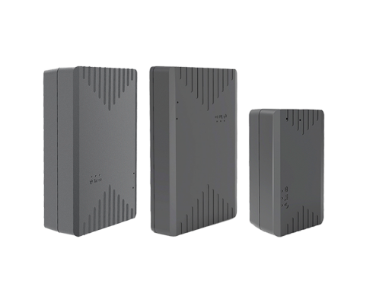
Engineered for high-risk asset protection where discretion is critical, the Vyskan VA05-Mag is an ultra-compact 4G LTE wire-free tracker. Striking an unparalleled balance between size and endurance, it houses a robust 5000mAh battery and 6 industrial magnets within a pocket-sized 78mm footprint. Delivering deep-sleep power efficiency and optical tamper alerts, it is the ultimate covert tracking solution for auto finance, rental fleets, and high-value cargo.
- Core Value
- Ultra-Compact Covert Deployment
Measuring just 78mm × 54mm × 21mm and weighing only 132g, the VA05-Mag is the smallest in its performance class. This extreme compactness allows it to be hidden effortlessly in the tightest spaces of vehicles or cargo.
- Slap-and-Track Instant Mounting
Equipped with 6 built-in high-strength NdFeB (Neodymium) ring magnets. It securely attaches to any metallic surface instantly, eliminating expensive wiring and installation labor costs.
- 5000mAh & Ultra-Low Power Consumption
Powered by a 5000mAh battery and a highly optimized power management system. In deep sleep mode, its working current drops below 2μA, maximizing standby longevity for long-term tracking scenarios.
- Optical Tamper & Removal Alert
Proactive security defense. A built-in high-sensitivity optical sensor detects environmental light changes, instantly triggering a drop-off/removal alarm to the platform if the device is maliciously detached.
- Target Applications
- Auto Finance & Car Rental: (Ultra-small size for covert concealment, optical tamper defense).
- High-Value Cargo & Logistics: (Instant magnetic mounting, wire-free deployment).
- Private Investigations & Auditing: (Pocket-sized footprint, silent operation, deep sleep mode).
- Technical Specifications
  - Cellular & GNSS
Category | Specification | Description
Communication Module | SIMCOM 7670C | Industrial-grade robust connectivity.
Network Bands | 4G LTE-FDD/TDD & 2G GSM | Customizable bands for global/regional requirements.
Positioning Chip | ZKMicro AT6558D | High-sensitivity satellite reception.
Positioning Mode | BDS + GPS + LBS + AGPS | Multi-constellation tracking for accurate visibility.
Start Time | Cold: Avg 32s |  Hot: Avg 1s | Rapid Time-To-First-Fix (TTFF).
Sensitivity | Tracking: -162 dBm | Maintains strong signal lock in challenging environments.
  - Power & Electrical
Category | Specification | Description
Battery Capacity | 5000 mAh (3.7V) | High density for extended standalone operation.
Operating Voltage | DC 3.4V - 4.5V | Internal battery power system.
Working Current | 30mA - 60mA @ 4V | Standard active tracking mode.
Standby / Sleep | Sleep: 5-15mA |  Deep Sleep: < 2μA | Industry-leading ultra-low power consumption.

  - Interfaces & Expandability
Category | Specification | Description
Anti-Tamper Sensor | Built-in Optical Sensor | Detects light changes to trigger instant removal alerts.
Data Cache | Blind Zone Compensation | Caches data during cellular drops for seamless upload upon reconnection.
External Interface | 3.3V Serial Port  (1 Channel) | Supports potential hardware expansions.
3.4 Physical & Environmental
Category | Specification | Description
Dimensions | 78mm × 54mm × 21mm | Pocket-sized, smallest in its class.
Weight | 132g | Extremely lightweight with integrated magnets.
IP Rating | IP65 | Dustproof and highly water-resistant.
Magnets | 6× NdFeB Ring Magnets (φ18*2.8mm) | Extreme industrial-strength adhesion.
Operating Temp. | -30℃ to 75℃ | Resilient operation in diverse climates.
- Built for Rapid Deployment & Integration
- Zero-Installation Design
The magnetic, wire-free design eliminates installation costs and allows for rapid fleet-wide rollout.
- Standard Protocols & Platform Directives
Easily integrates with leading tracking platforms. Supports pre-configured platform directives that automatically download to the device once it wakes up and connects to the network, significantly improving operational efficiency.
- A personalized service prepared for you
- 1× VA05-Mag Sample Device (Pre-configured)
- Full API & Protocol Documentation
- 1-on-1 Technical Support from our Field Engineers
- Contact us
Website: https://vyskan.com/
Email: marketing@vyskan.com

